Oblig 2
Simon Myhre

1.
When a computer is using an application, then it is in user mode. But when it needs any hardware resource, it requires the kernel mode. User mode is made so it is easy to interact with pc. It is made simple. Because of that it has a limited access to the hardware. But in kernel mode it is different. There it is not simple to navigate. Or let say, find the memory hardware. It requires experience. But it has access to everything. So: Kernel mode: A software that has access to the hardware. But is difficult to navigate/to use. User mode: Easy to navigate. But has a limited access to the hardware.
Some differences:
Kernel mode = Privileged mode. User mode: Restricted mode
Kernel mode = Processes get single address space. User mode = Processes gets their own address space
Kernel mode = If fail, the hole OS may go down. User mode = If fail, only one/the process go down
User mode has restricted access to Kernel mode programs

https://www.differencebetween.com/difference-between-user-mode-and-vs-kernel-mode/
https://www.tutorialspoint.com/User-Mode-vs-Kernel-Mode

2.
False - Bash shell or any type of shell is a program that complements the OS

False – A third party copying program is an add-on to the OS. Not build in if that is the question

False - The user mode gets a system call to kernel mode that gets the needed “hardware”. Then kernel mode returns this call.
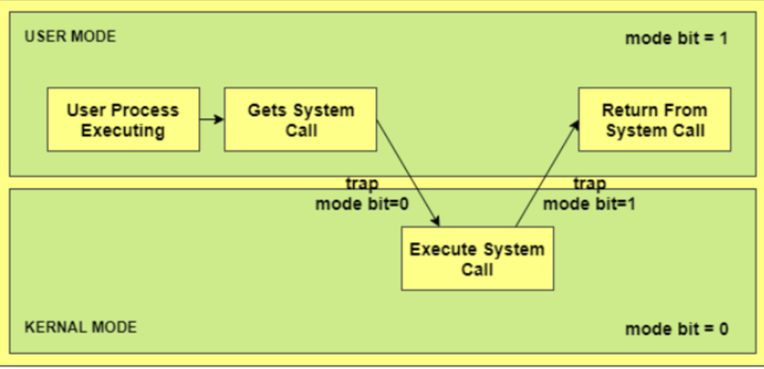

False - Interrupts are uses to check for input or when/if an output is completed.

False – In Kernel mode you can do whatever. But the system might crash

True – Or. The OS gathers data from the I/O device. It needs some kind of interface to understand the data. But yes. If data from the /O device is files, then its true

True – The process table stores the suspended processes. So when they are restarted it is as they have never been stopped

True – Yes. It allows multiple processes to work

https://encyclopedia2.thefreedictionary.com/process+table
https://minnie.tuhs.org/CompArch/Lectures/week05.html

3.
It can be used, but it is not recommended. That is because it has too much software that is not used. It will only “be in the way”, and make the sensor slower. But probably the sensor doesn’t even have enough space for that OS. That’s why sensor run a different and much simpler OS. Like TinyOS. Its designed to not draw that much power. And should also not require “work” form the cpu, ram esc.

4.
When a program calls a system call it means it need something in the Kernel mode. That is expensive and we doesn’t want that to happened way to often. Expensive = time. So it goes from User mode (bit 1) to Kernel mode (bit 0). Then does the work it is asked to do. Then goes returns the system call back to User mode (bit 1).

5.
- It can go from ready to blocked. Or blocked to running. Those two are missing. While its not written in the book I guess there are ways for it to go from ready to blocked. That’s because something can happen. Lets say a I/O device is unplugged. That may have been the input it needed to be ready. But now its not ready anymore because it no longer has the input it needs. That’s why it will be put back to blocked and keep waiting for input. Or lets say the memory block where removed/needed to be removed. Then it could go from blocked to running or ready to block
- CPU utilization = 1 – n^p = 1 – 0.4^6 = 0,995.
- I will have to “turn” the formula. So that I have I/O wait on one side. And on the other side I will need to just plot in 0,99 for utilization. 1 and the number of processes (14) that is allowed. Then I will find how much wait time is allowed. Or if I just do 1-0.1^14 I get = 0,9999999 as a result. That means 01 is correct. But it is not the correct way to figure it out
- 50% of 20 is 10. 20+10 is 30. 30 minutes for it to run parallel. Sequentially is 20+10+20+10 = 60. 60 minutes for sequentially run
6.
Variables are values set to a word. So, basically you store information for you to use later, or with something later. It can be a numbers and characters. Depending on what type you set the variable to be. Local variables are variables made inside a function. It will only be able to access inside that function. That means it is possible to have a different variable with the same name in a different function, because they don’t connect, because it is local. But if you write a global variable. A variable “made” outside of a function It can be accessed by everyone. That also means you cant have another variable with the same name inside a function without changing the global variable.
Then you have the static. Those are meant to be initialized only once. And like variables it can be global or local. Just like the variable the global can be accessed by everyone but the local can only be accessed withing the same function. Static variables are f.eks. static main. So if you run a loop the static variable will remember the last value it was, instead of being initialized again

7.
- The a, b over void foo are global. The rest are local
- It outputs first the foo(). Where a = 1, b = 1000 and c = 10. Then it prints the main(). Here a = 2, b = 2000 and c = 20
- There will be no output if we remove line nr. 5. That’s because a=10, b=… requires to be told what type it is. Because it they are now global variables. Anyway there are a lot of small things that needs to be fixed before the program will work without line 5. Like removing foo() call in void main().

8.
- 2048 because of the static variable. The static variable does so the variable isn’t initialized again
- If we remove the static variable b and c will be 4. Because every time the loop goes for another round b will first be set to 2. Then *2. Then c = b.
- That’s because b is local inside that for-loop block.

9.
- The amount of child processes depends on how many time the fork will be run. If the loop goes 1 time. The fork() will split it to 1 child and 1 main. If it loops 2 times it will fork the child process into 2. And the main into 2. So it will be 2^n.
- There will be a “main” process in every fork(). So it will come a “main” process from a child process.
- Fork bomb is simple. When you fork() you split the “line” in two. And if you fork again you split those 2 lines in 4. And then 4 will be 8... It continues to loop it will be so many processes that it crashed because there are too many processes to be handled. That’s why it’s a bomb.

10.
- I didn’t really understand what y and x = a means. Because a = a+5 or a-5. But what I did understand is the if-sentences. If(fork()=0) it means we are in the child process. Because child process will be 0. Error will be -1 and the main will have its own ID. So if its not ==0 that means (else) we are in the main process. So, the main process is a-5. And the child process is a+5. So a will be different in the child process compared to the main process.

11.
Added “&” to line 6, because that’s the syntax. Added “==” to line 10. “=” means a will be like b, not is a equal to be.

